**EMBEDDED SYSTEM DESIGN**

**LAB ASSIGNMENT - 7**

# Implementation of ADC & UART ON ARM

**SUBMITTED BY- ABHINAV GARG (2016H140103P)**

**SANCHIT AGRAWAL (2016H140106P)**

**OBJECTIVE:** To get the analog data from potentiometer, convert it into digital data. Then send the same data to the asynchronous serial link (UART) & display the same data on the LCD. Enable serial communication between PC and microcontroller using UART link.

**PROJECT WORKSPACE:**

* Used keil u-vison5..
* Under ARM section, select the board as LPC 2148.
* Include all the header files and the source files that are required for the program
* Project explains about ADC, UART, and LCD functionality of blueboard.
* Workspace consists of all the library files.
* Then, after ARM programming, select the target device that is to be programmed and burn the bin file into the device.

**CRITICAL ISSUES-**

* A proper delay must be ensured while displaying data on LCD**.**
* Baud rate should be matched between master & slave for proper data transmission.
* Monitor TXE bit to ensure the frame of data has been transmitted and TC bit for successful data transmission

**METHODOLOGY:** We configure registers of LPC2148 to enable LCD (16x2) . ADC0.3 is used to get the analog data from potentiometer. It is converted into the digital data by configuring ADC registers.

Configure various UART registers to enable UART0 for serial communication. .PL2303 USB to serial converter module is used to communicate with the PC.

**HARDWARE REQUIREMENT:**

* LPC2148 development board
* PL2303 Prolific USB to serial converter module

**HARDWARE DESIGN:**

* P0.30 bit of Port0 is used as channel 3 of ADC 0.
* P1.21, P1.22,P1.23 are used as Enable, Read/Write, RS pins of LCD respectively
* P0.10, P0.11, P0.12, P0.13 are configured as D4, D5, D6, D7 (data pins) of LCD respectively.
* P0.0, P0.1 are used to Transmit and Receive data to the serial port.
* Schematic is as shown in as figure below

**Schematic for Implementing UART, ADC operation and display data on LCD:-**

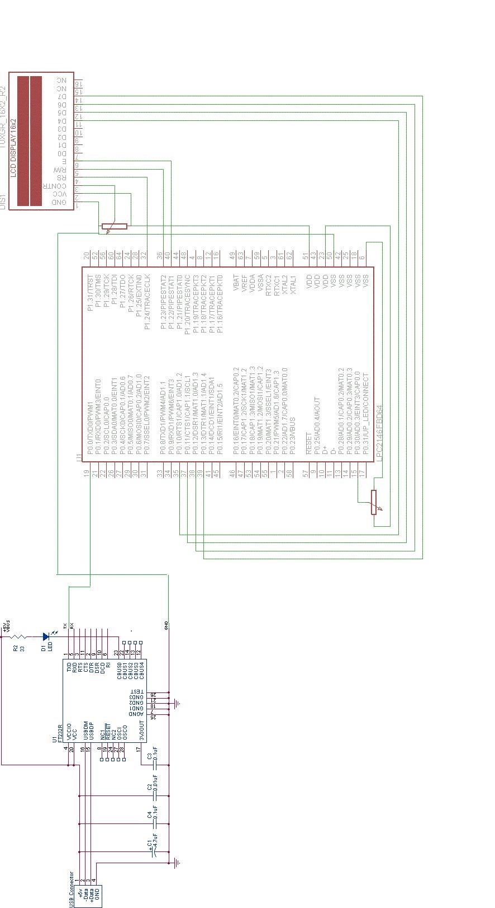

Figure showing schematic diagram of interfacing UART, ADC and LCD with LPC2148

**SOFTWARE DESIGN-**

**LCD:**

* Write command to LCD set RS to ‘0’
* Set all the pins of the port used by LCD as output port.
* LCD is configured , by sending the following commands:

* 1. 0x02 : Initialize LCD in four bit mode
  2. 0x06 : Entry mode (cursor movement)
  3. 0x0c : Display on cursor off
  4. 0x80 : Cursor indicating first line & first position
  5. 0xc0 : Cursor indicating second line & first position
* Our LCD is working in 4 bit mode so we are passing the 8 bit data as 4 bit at a time by masking
* While passing data set RS to ‘1’.
* The data is transmitted character by character and is displayed on the LCD

**ADC:**

* + Configure ADC registers to set clock prescaler
  + select the channel to receive analog input at the ADC input pins.
  + Select 10 bit mode of operation. Select the burst mode of operation.
  + Wait until the conversion complete by checking MSB bit of “AD0GDR” and then send that value to UART & ADC.

**UART:**

* + Select UART 0 by setting suitable value on Pin-select register.
  + Initialize U0LCR to select 8 bits, no Parity, 1 Stop bit.
  + Initialize U0DLL & U0DLM to set the baud rate of 9600.  Set DLAB bit of U0LCR.
  + The data is sent through ‘UOTHR’.
  + Wait until data is sent is achieved by 5th bit U0lSR register.
  + The control flow is shown in the below diagram:

**FLOW CHART**

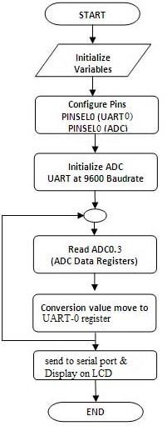

* + **Observation:**

Success in reading the analog input from ADC pin and converted Data is transmitted to PC terminal via UART0 and the same value is shown on the LCD.

* + **Result:**

The analog data has been converted into digital successfully and the result

was observed on PC and LCD display.

**References:**

<http://www.electroons.com/><https://codeload.github.com/binaryupdates/>google images